**Noise Pollution Monitoring using IoT**

**Phase-1 Document submission**

**TEAM MEMBER**

**NAME: K RAKESH SARAN**

**Reg No: 411421104038**

**Project: Monitoring environmental noise pollution.**

Phase-1: ****Problem Definition and Design Thinking****

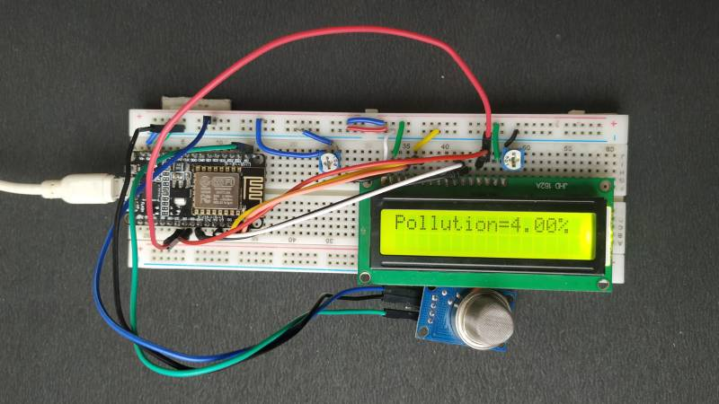

On basis of Real time Environmental noise reading

**Objective:**

To develop an IoT-based noise monitoring system that assesses and records ambient noise levels in different areas, providing real-time data for identifying noise pollution hotspots and facilitating informed environment planning and noise abatement measures.This project aims to contribute to improved quality of life for residents by enabling local authorities to implement noise control strategies and policies based on data-driven insights, ultimately reducing the negative impact of noise pollution on public health and well-being.

**Problem Definition:**

Urban areas are increasingly affected by noise pollution, which can lead to adverse health effects, reduced quality of life, and disrupted ecosystems. However, there is a lack of real-time and accurate data on noise levels in specific locations, hindering effective urban planning and noise control measures. The problem is to develop a comprehensive noise monitoring system that can provide reliable, continuous data on noise pollution, enabling authorities to identify problem areas, implement targeted interventions, and promote a quieter and healthier urban environment.

**Technical Feasibility:**

To apply sound monitoring system where its objective is to measure the sound in the environment, Arduino is used and senors like sound sensor is connected to it. Sound sensor or mic sensor provides digital output and it detects sound from atmosphere. A WiFi module is also connected to Arduino and it is used to transfer data from the sensors to cloud server. ESP8266 WiFi module is used to store the data to online server.The data from sensor are basically analog signal so analog to digital converter (ADC) is used to convert the data.16 x 2 Liquid crystal display (LCD) is used to display the measured value from the sensors. It can display two lines and each line has 16 characters.

**Hardware Development:**

For the hardware development, LM 393 sound sensor is used to read the readings of the sound level from the environment. The reading of sound sensor is calibrated using the real sound level meter to get the accurate readings of the sound level. The 16x2 LCD will show the values of sound level at that researched area and give the warning that says the level of sound is high when the measurement exceeds the set value. If the users could not read the readings due to poor eyesight,they can know the level of sound by using the light emitting diodes (LED) which in red, blue and green colour placed below the LCD. LED acts as an indicator to indicate when the noise is very high. It will turn to red, blue for low noise while green for intermediate level. All these components such as sound sensor, LCD, and LEDs will be connected to the ESP8266 NodeMCU.

**Required Hardware:**

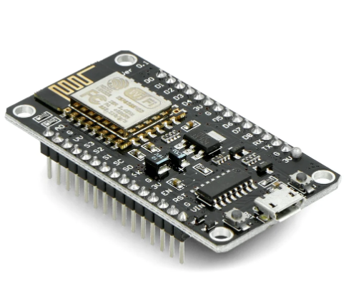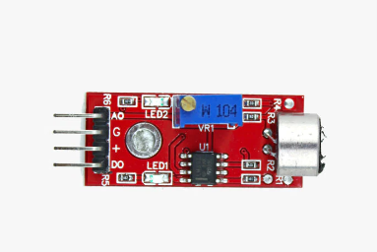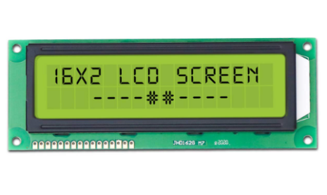

16x2 LCD

LM 393 sound sensor

ESP8266 NodeMCU

**Module Deployment:**

The sound sensor will record the readings of sound level at the researched area. Then, the data is sent over to the cloud server which is specialized for web application and mobile apps. The data is stored in real-time database which the user can also access via web application. Then, data from database is transferred to the app.The users can use the app to know the reading of sound level in dBA, the level of warning based on the reading of sound intensity, the possible sound that contributes to the sound level. The app gives different level of warning such as “low”, “normal”, “high” and “very high”.

**Phase-1 deliverable:**

1. **List of engineered features:** Document all the newly created features along with their descriptions and how they were calculated. This list should make it clear how each engineered feature adds value to the predictive model.
2. **Design Thinking:** Design thinking is used to understand the needs and pain points of urban communities affected by noise pollution. By empathizing with residents, city planners, and environmental experts

**Conclusion:**

The sound sensor will record the readings of sound level at the researched area.Then, the data is sent over to the cloud server which is specialized for web application and mobile apps.The data is stored in real-time database which the user can also access via web application. Then, data from database is transferred to the app.The users can use the app to know the reading of sound level in dBA, the level of warning based on the reading of sound intensity, the possible sound that contributes to the sound level. The app gives different level of warning such as “low”, “normal”, “high” and “very high”.